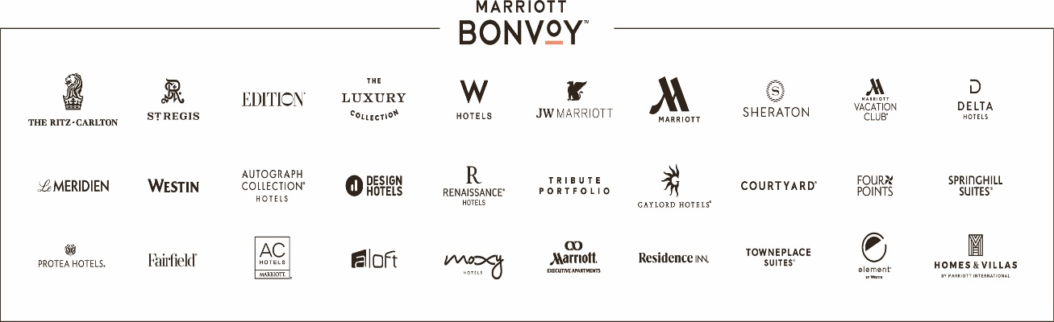
TO: | General Managers  U.S. & Canada Full-Service Managed Properties  Invitation to participate Full-Service Franchised Properties
DATE: | January 1, 2023
SUBJECT: | 2023 Marriott Children’s Miracle Network Hospitals Breakfast Campaign

General Managers:
Our goal is to have all managed hotels participate in this program where appropriate to support their local Children’s Miracle Network (Hospitals), which collectively provide $2.5 billion in charity (uncompensated) care each year. We invite all franchised hotels to participate as well. As in previous years this annual campaign requires a low level of logistical effort and can produce extraordinary results for CMN Hospitals.
Here are the details:
- Please inform your AVP that you wish to participate in the campaign.
- Once approved by your AVP, inform your ownership that you wish to participate in the campaign.
- If participating, the campaign should be run for 90 days of your choice, ideally during your peak season.
- Given the extraordinary circumstances the Covid pandemic has created, you may need to exercise some creativity in choosing a menu item(s) to increase by $1.00 as breakfast buffets may not be permissible.
- As in previous years, our guidance remains the same - Hotels should not position this campaign as an optional guest donation (verbally, in print, on flyers, or menus, etc.) – either one where guests can remove a dollar from their bill (“Opt Out”), or one where the guest is asked if they want to participate by allowing a dollar to be added to their bill (“Opt In”). Participating hotels are simply exercising their right to increase the price of an item and this is noted on the menu with appropriate CMN TAG. This identifier ‘Tag’ should be adjacent to the item and a note should be added at the bottom of the menu stating, “We are proudly supporting Children’s Miracle Network (Hospitals) with a $1.00 donation with every breakfast buffet or entrée sold.”
  - (Feel free to call it “Miracle Breakfast” on your menu).
- At period end, run a menu item sales by outlet report. The item (i.e., breakfast buffet / entree) should be identified and the item count multiplied by $1.00. Make a journal entry reducing the outlet’s sales by this amount. When tax is submitted, tax must be paid on the full menu price (inclusive of the $1.00 donation).

Visit http://marriott.childrensmiraclenetworkhospitals.org/ for details on how to submit donations. Please direct any questions related to the breakfast campaign or other CMN Hospital programs or events to Amy.Moyer@Marriott.com.

