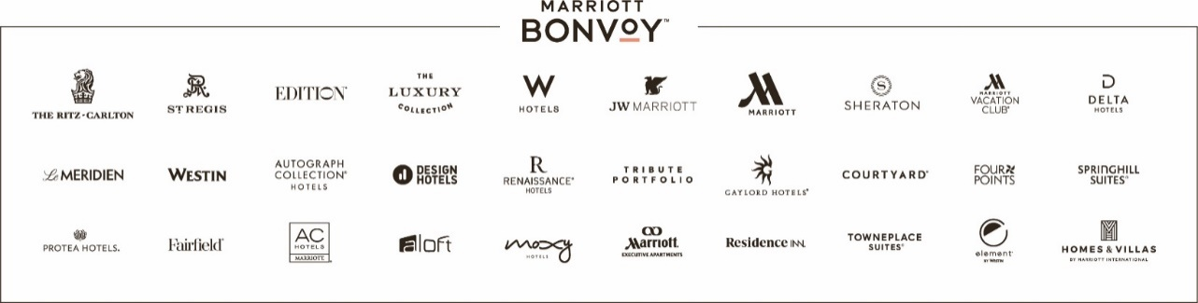
TO: | General Managers  The Americas, Managed and Franchised Properties
DATE: | January 1, 2023
SUBJECT: | 2023 Marriott Bonvoy Promotion to support Children’s Miracle Network Hospitals: “Use Your Points To Do Good”

General Managers:
We invite all hotels to participate in this program in support of the 170 Children’s Miracle Network (Hospitals) in the U.S. and Canada. This campaign requires a low level of logistical effort and can produce extraordinary results. Here are the details:
- Inform your ownership that you will participate in the promotion
- Post the approved / provided marketing poster
  - Poster: color print on large, foam core
- Display to Marriott Bonvoy Members
  - Suggestions: Poster on an easel in the M Club, Flyer in a frame at the front desk stations or lobbies to encourage our guest to donate their points to support Children’s Miracle Network Hospitals. All guests need to do is scan the QR code with their camera on their phone and it will pull up the site which will give them the options on how they can donate points or visit the link:
Click Here to donate points to your local Children’s Miracle Network Hospital.
- The donated points will be converted to cash in the equivalents listed on the https://giving.marriott.com/ site. The cash donation will in turn be donated to the Marriott Bonvoy members local Children’s Hospital. The donors zip code on their profile will determine donation location. Donations are made on a quarterly basis to Children’s Miracle Network Hospitals.

Please direct any questions related to the Bonvoy campaign or other CMN Hospital programs or events to Amy.Moyer@Marriott.com.

