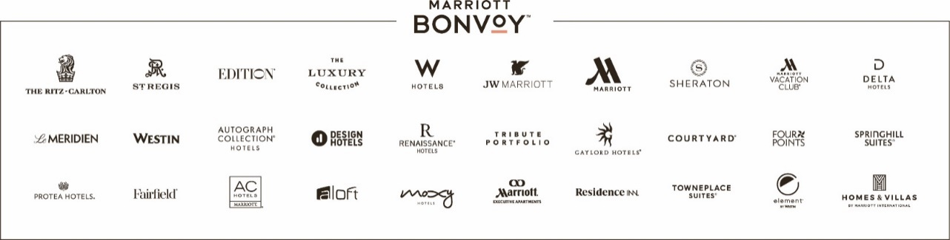
TO: | General Managers  The Americas, Managed and Franchised Properties
DATE: | January 1, 2023
SUBJECT: | 2023 Marriott Casual 4 Kids to support Children’s Miracle Network Hospitals

General Managers:
We invite all hotels to participate in this program in support of the 170 Children’s Miracle Network (Hospitals) in the U.S. and Canada. This program is a fantastic associate engagement activity that allows everyone to participate and support CMN Hospitals.
Here are the details:
- Casual 4 Kids days are selected by each hotel: weekly, monthly, quarterly, or even just once a year.
- Post the Casual 4 Kids poster(s) in the heart of the house area(s) for all associates to see with dates of scheduled days and amount of requested donation to participate.
- To purchase Casual 4 Kids stickers for participating associates to wear here.
- To purchase Marriott and Children's Miracle Network Hospital branded items click here.
- If you have any questions please reach out to Amy Moyer at Amy.Moyer@marriott.com.
Please direct any questions related to the Root Beer Float Day activity or other CMN Hospital programs or events to Amy.Moyer@Marriott.com.

